Python Question Paper

Subject: Python Programming

Topic: File Handling

Total Questions: 10

Instructions:  
- Write Python programs to solve the following problems.  
- Use appropriate file handling modes and exception handling where necessary.

# Section A: Basic File Operations (Q1 - Q3)

Q1. Write a Python program to create a text file named `sample.txt`, write your name and a message into it, and then close the file.

Q2. Write a program to read and display the contents of `sample.txt`.

Q3. Write a Python script to append a new line `"This is an appended line"` to `sample.txt` and display the updated content.

# Q1: Write a Python program to create a text file named `sample.txt`, write your name and a message into it, and then close the file.

file = open("sample.txt", "w")

file.write("Sujana D\n")

file.write("Hello, this is my first file handling program.")

file.close()

# Q2: Write a program to read and display the contents of `sample.txt`.

file = open("sample.txt", "r")

content = file.read()

print("\nQ2: File content:")

print(content)

file.close()

# Q3: Write a Python script to append a new line `"This is an appended line"` to `sample.txt` and display the updated content.

file = open("sample.txt", "a")

file.write("\nThis is an appended line.")

file.close()

file = open("sample.txt", "r")

updated_content = file.read()

print("\nQ3: Updated file content:")

print(updated_content)

file.close()

**OUTPUT (1- 3)**

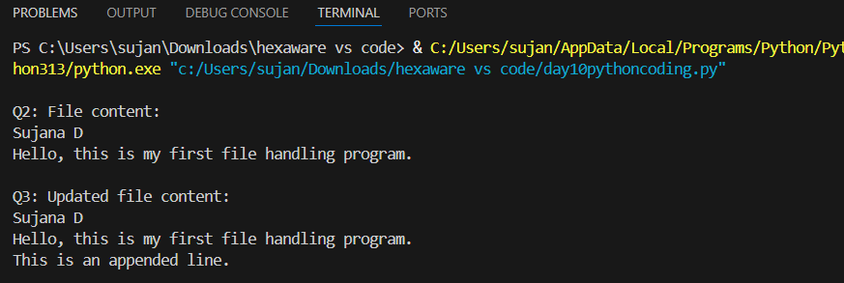

# Section B: File Processing and Analysis (Q4 - Q7)

Q4. Write a Python program to count the total number of lines in a given file `sample.txt`.

Q5. Write a Python program that reads a file and prints only those lines that contain the word “Python” (case-sensitive).

Q6. Write a Python program to count the number of words and characters in the file `sample.txt`.

Q7. Write a program to copy the contents of `sample.txt` to another file `copy_sample.txt`.

# Q4: Write a Python program to count the total number of lines in a given file `sample.txt`.

file = open("sample.txt", "r")

lines = file.readlines()

print("\nQ4: Total number of lines:", len(lines))

file.close()

# Q5: Write a Python program that reads a file and prints only those lines that contain the word “Python” (case-sensitive).

file = open("sample.txt", "r")

print("\nQ5: Lines with the word 'Python':")

for line in file:

    if "Python" in line:

        print(line.strip())

file.close()

# Q6: Write a Python program to count the number of words and characters in the file `sample.txt`.

file = open("sample.txt", "r")

text = file.read()

words = text.split()

characters = len(text)

print("\nQ6: Total words:", len(words))

print("Q6: Total characters:", characters)

file.close()

# Q7: Write a program to copy the contents of `sample.txt` to another file `copy_sample.txt`.

file1 = open("sample.txt", "r")

file2 = open("copy_sample.txt", "w")

file2.write(file1.read())

file1.close()

file2.close()

print("\nQ7: File copied successfully to 'copy_sample.txt'")

**OUTPUT (4-7)**

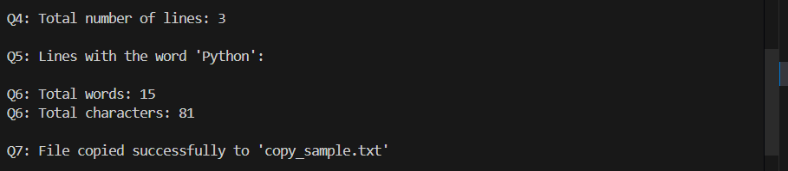

# Section C: Advanced File Handling (Q8 - Q10)

Q8. Write a Python program to display the last 3 lines of a text file.

Q9. Write a Python program that reads numbers from a file `numbers.txt`, one per line, and writes only the even numbers to a new file `even_numbers.txt`.

Q10. Create a program that accepts user input (name, age, city) and stores it in a CSV file `users.csv`. Ensure that every new entry is stored on a new line.

# Q8: Write a Python program to display the last 3 lines of a text file.

file = open("sample.txt", "r")

all_lines = file.readlines()

print("\nQ8: Last 3 lines from the file:")

for line in all_lines[-3:]:

    print(line.strip())

file.close()

# Q9: Write a Python program that reads numbers from a file `numbers.txt`, one per line, and writes only the even numbers to a new file `even_numbers.txt`.

file = open("numbers.txt", "w")

file.write("10\n15\n22\n33\n44\n55\n")

file.close()

file = open("numbers.txt", "r")

even_file = open("even_numbers.txt", "w")

for line in file:

    num = int(line.strip())

    if num % 2 == 0:

        even_file.write(str(num) + "\n")

file.close()

even_file.close()

print("\nQ9: Even numbers saved to 'even_numbers.txt'")

# Q10: Create a program that accepts user input (name, age, city) and stores it in a CSV file `users.csv`. Ensure that every new entry is stored on a new line.

import csv

print("\nQ10: Enter your details to save in users.csv")

name = input("Enter your name: ")

age = input("Enter your age: ")

city = input("Enter your city: ")

file = open("users.csv", "a", newline="")

writer = csv.writer(file)

writer.writerow([name, age, city])

file.close()

print("Q10: Your data has been saved to users.csv")

**OUTPUT (8-10)**

